***Mobile Application Development Lab***

***CSL-341***

***Lab Journal***



**Student Name:** Abdul Wassay

**Enrollment No:** 01-134222-006

**Section:** BSCS(6-B)

**Department of Computer Science**

# BAHRIA UNIVERSITY ISLAMABAD

## Lab 2 – Dart Introduction

Objectives:

Basic syntax of Dart programming language

Tools Used:

VS Code

Submission Date:

Evaluation Signatures of Lab Instructor

TASK 1:

**Find the largest number in a given list.**

**Solution:**

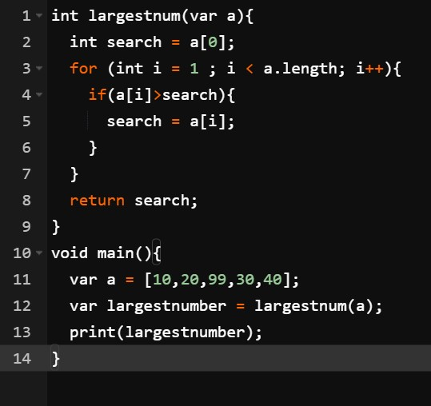

**Output:**



TASK 2:

**Use merge sort to sort a List.**

**Solution**

**:**

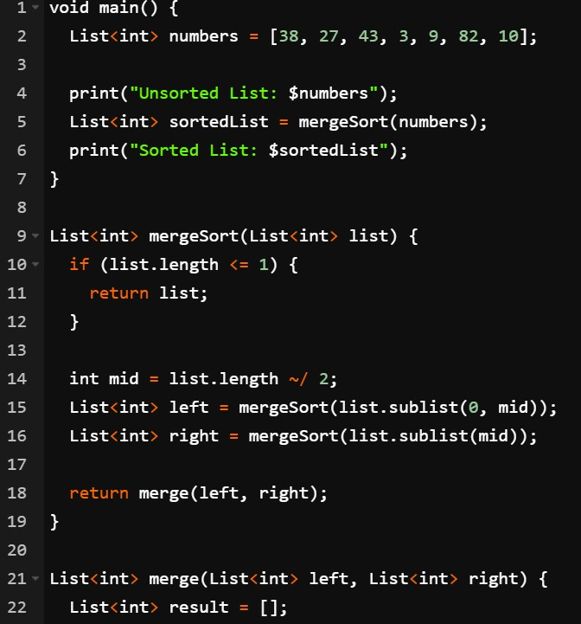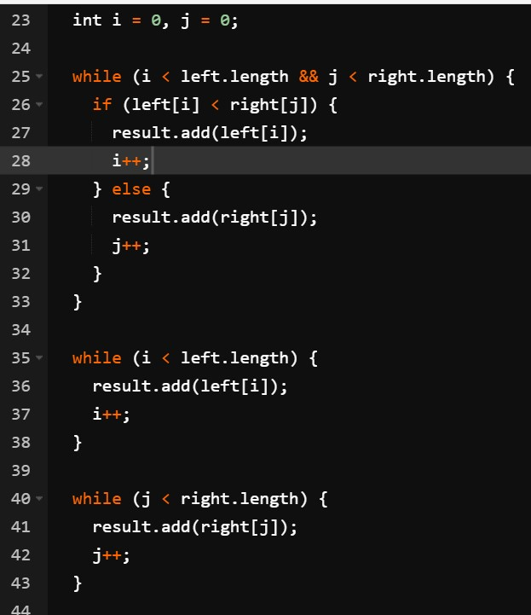

**Output:**

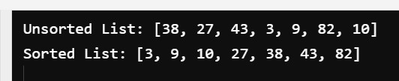

Task 3:

**Implement a Stack from Scratch.**

**Solution:**

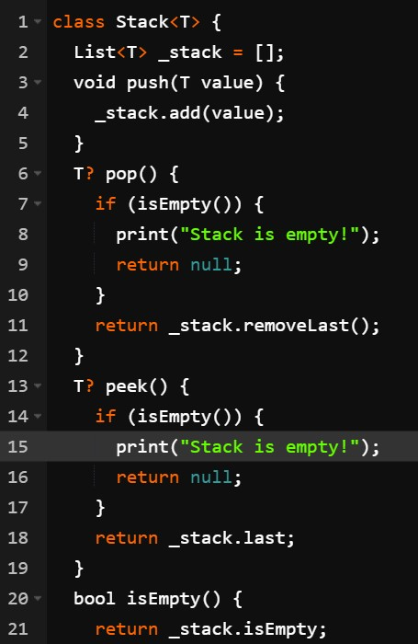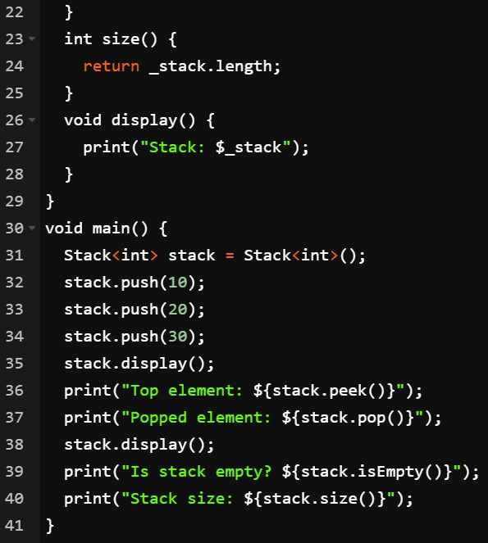

**Output:**

